**Section 6 - The Downfall of Rotary Engines**

**Preface - Advantages vs Disadvantages**

The theorical advantages of rotary engines are:

* compactness
* low vibration magnitude level
* absence of valves for the intake and exhaust
* light weight;
* low noise.

The main disadvantages of rotary engines are:

* friction of the apex seal
* combustion - bound by the geometry of the rotor and the statoric case.
* non-homogeneous temperatures of the statoric case - requires an accurate study of the cooling system.

**6.1 - Environmental Impact**

The Wankel rotary engine has been neglected as time has progressed. This is mostly due to the its destructive environmental impact, most problematic being it's emissions of carbon monoxide and low thermal efficiency. This is primarily due to the long combustion chamber and unburnt fuel making its way to the exhaust and being outputted as fumes into the environment.

Emissions are poor also due to terrible fuel economy within rotary powered vehicles. This was one of the primary causes of the death of rotary powered vehicles.

Furthermore, the increase in the Climate Change Emergency has resulted in the manufacturing industry and market to steer away from employing this design within future production. Hence, in order to increase appeal, sales, sustainability and economic profit, research into the rotary is very limited in areas of society and engineering with the rotary engine.

**6.2 - Design Short-Comings & Limitations**

The intake and combustion occurs simultaneously as previously mentioned in earlier sections of this blog, therefore, the top of the housing of the rotor is cool while in contrast the bottom of the housing is much hotter. This consequently means various sealing issues arose with wear, caused by metal-to-metal seals within operations of high temperatures. Furthermore, this was problematic as coolant jackets would be required to help in evening out the heat load, but the issue would still not be fully diminished.

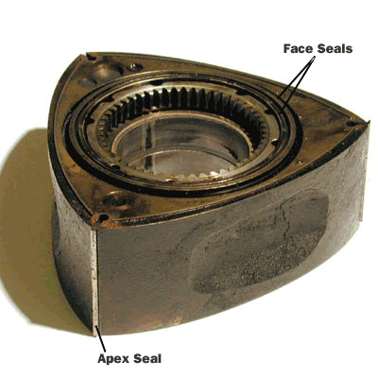

*Figure 1 - Three Convex Faces/Seal Locations*

[*Image Source*](http://www.formula1-dictionary.net/wankel_engine.html)

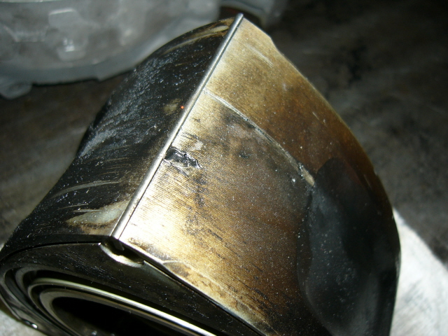

*Figure 2 - Blown Apex Seal Signs*

[*Image Source*](https://www.rx8club.com/series-i-major-horsepower-upgrades-93/broken-apex-seal-signs-90696/)

Similarly, oil consumption occurs in only one portion of the engine, reducing the lubrication required in assisting to keep the rotor sealed. The following is a great video summarising the discussion within this section and simplifies the down fall of the rotary engine.

[Video Source](https://www.youtube.com/watch?v=v3uGJGzUYCI)

**References:**

[1] - Fenske, J., 2018. *4 Reasons Why The Rotary Engine Is Dead*. [online] DriveTribe. Available at: <https://drivetribe.com/p/4-reasons-why-the-rotary-engine-EYecj2yqQheXGcQwtlwVsg?iid=KqwptyciRc-LauxwRhzR-Q> [Accessed 21 May 2021].

[2] - Jacobs, C., 2016. *Don't Expect to See Any Rotary Cars for a While*. [online] The Drive. Available at: <https://www.thedrive.com/article/6357/dont-expect-to-see-any-rotary-cars-for-a-while> [Accessed 21 May 2021].

[3] - Formula1-dictionary.net. n.d. *Wankel Engine*. [online] Available at: <http://www.formula1-dictionary.net/wankel_engine.html> [Accessed 21 May 2021].